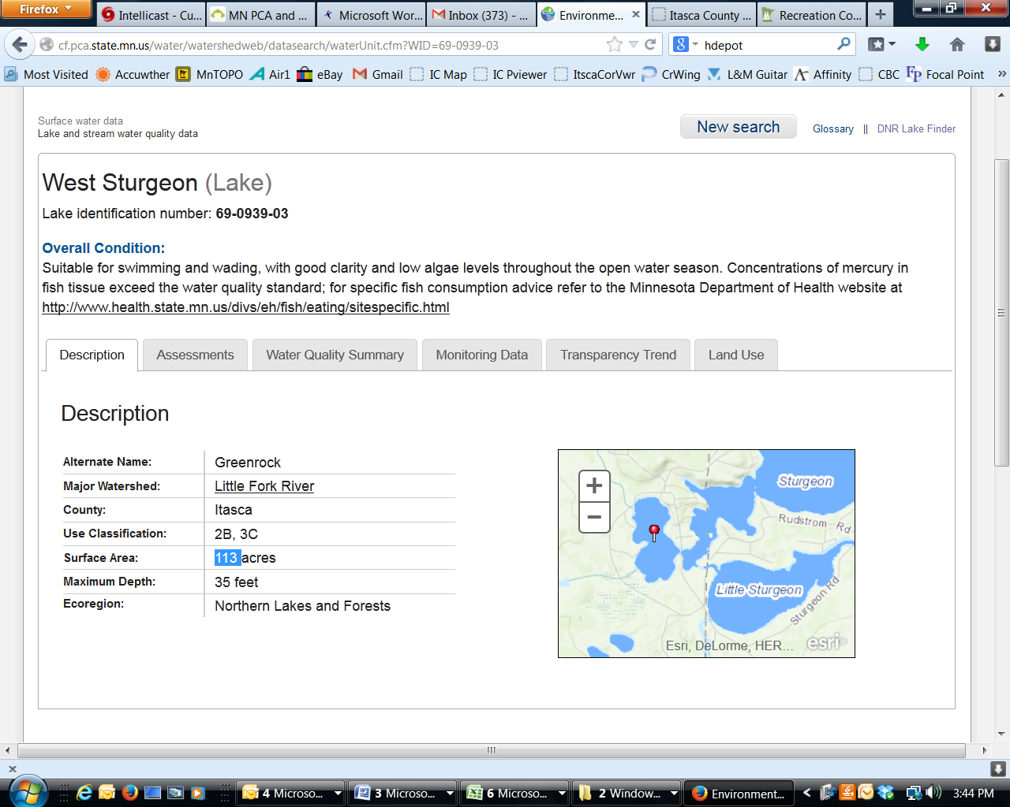**West Sturgeon Lake**

DNR Lake ID: 69-0939-03-202

County: St. Louis-Itasca

Major Watershed: Little Fork River

Ecoregion: Northern Lakes and Forests

Surface Area: 113 acres

Maximum Depth: 35 feet

Water Quality Data: 4 years

Secchi Data: 9 years

## 2015 Water Quality Summary

Clarity monitoring results for West Sturgeon Lake in 2015 were overall below (worse than) the lake’s historical average and nearing the upper range for this region. The trophic status of West Sturgeon Lake is mesotrophic to borderline eutrophic which means the lake is near a threshold where it likely experiences problems with algae blooms and macrophyte problems (submergent vegetation growth). Although it is supportive of all swimmable/aesthetic uses it may experience periods each year where recreation is inhibited, but due to the high tannin stain of the water algae blooms are limited in comparison with lakes that are clearer. Although the lake is classified as borderline eutrophic, further study is required to determine if its current status is a result of natural conditions or anthropogenic (human) causes.

**West Sturgeon Lake Water Quality**



**Carlson’s Trophic Status Index (TSI) – West Sturgeon Lake Historical Average**





*Note: Trophic State Indices (TSIs) are an attempt to provide a single quantitative index for the purpose of classifying and ranking lakes, most often from the standpoint of assessing water quality. TSIs ranges from clear lakes, low in nutrients (oligotrophic), to green lakes, with very high nutrient levels (hypereutrophic).*

## Historical Water Quality Summary

West Sturgeon Lake’s historical data for total phosphorus, chlorophyll-a, and secchi do not meet the minimum requirements (10 years of data) for looking at trends. The clarity (secchi depth) has shown a pretty significant decrease since monitoring began in 2002. The past three years have been significantly lower clarity than the previous six years, warranting continued annual monitoring and increased vigilance.

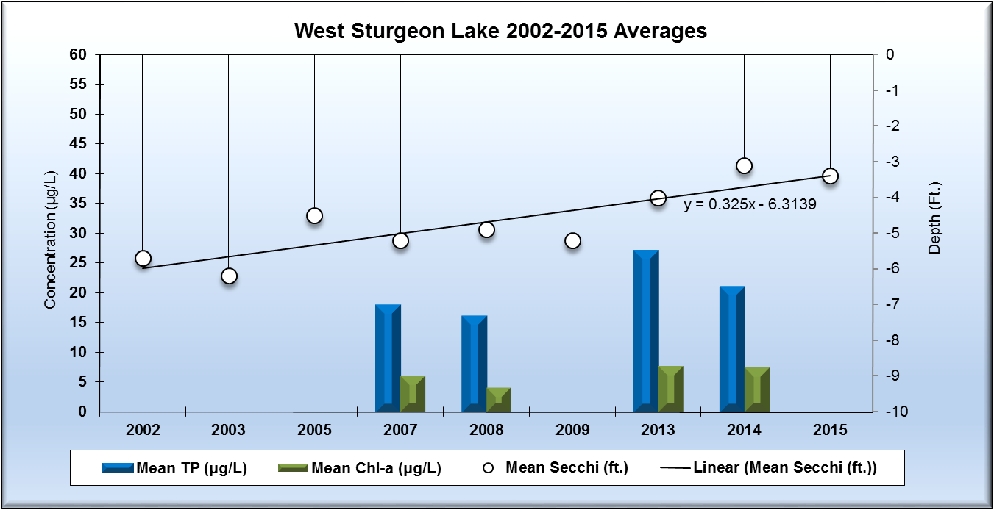

*Note: For detecting trends, a minimum of 8-10 years of data with 4 or more readings per season are recommended. Minimum confidence accepted by the MPCA is 90%. This means that there is a 90% chance that the data are showing a true trend and a 10% chance that the trend is a random result of the data.*

**Monitoring Recommendations**

Transparency monitoring at site 203 should be continued annually. It is important to continue transparency monitoring bi-weekly or at least monthly every year to enable year-to-year comparisons and trend analyses. Phosphorus and chlorophyll-a monitoring should continue at site 203, annually or every 2-3 years, as the budget allows. This would enable the establishment of water quality trends once there are 8-10 years of chemistry data. Since there is an apparent decline in the clarity since 2002, this lake should be watched closely into the future to see if these preliminary “trends” continue, or if it is the result of some anomaly in the data taken thus far. RMB Labs, based in Detroit Lakes would be a recommended resource for Water Quality lab services as well as statistical reporting. RMB has a highly skilled staff with a robust background in statistics and chemistry, coupled with a convenient sample transport system between Spee-Dee Delivery Services and RMB Labs. RMB has opened a sister Water Quality Lab at Itasca Community College as of January 2016, and will be a good local resource for general water quality analysis.