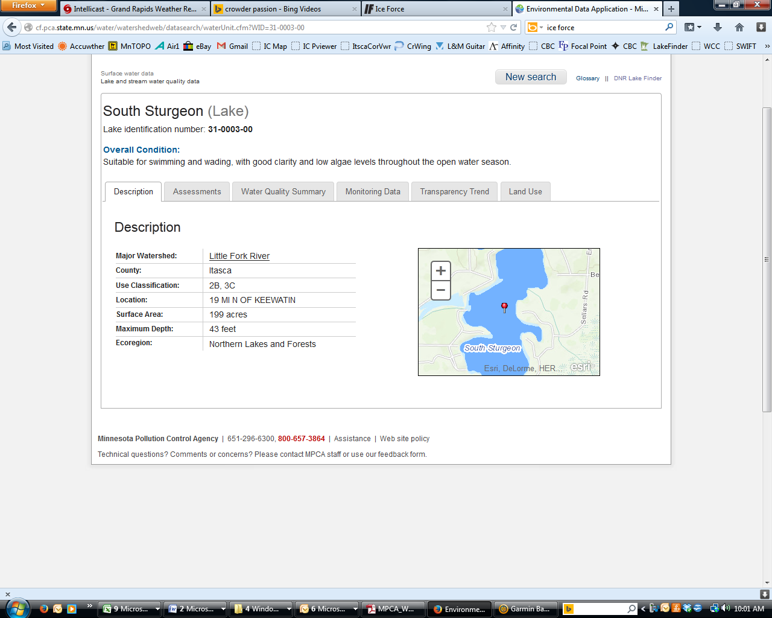**South Sturgeon Lake**

DNR Lake ID: 31-0003-00-201

County: Itasca

Major Watershed: Little Fork River

Ecoregion: Northern Lakes and Forests

Surface Area: 199 acres

Maximum Depth: 43 feet

Water Quality Data: 5 years

Secchi Data: 29 years

## 2015 Water Quality Summary

Clarity monitoring results for South Sturgeon Lake were very close to the lake’s historical average in 2015. Meanwhile, the water clarity average was quite low for 2014, and high in 2013. In recent years the secchi depth (clarity) seems to be fluctuating quite a bit. Total Phosphorus and Chlorophyll-a were not monitored for 2015, however the lake should be monitored intermittently as funding allows in the future, which would contribute to a reliable trend. The overall trophic status of South Sturgeon is mesotrophic, but with years like 2013 it is bordering eutrophic conditions where algae blooms can begin to become a problem during certain periods of the summer by restricting recreational use. South Sturgeon Lake has a very dark tannin (root beer) stained color, which is natural and can actually benefit the lake because limited light penetration inhibits algae growth.

**South Sturgeon Lake Water Quality**



**Carlson’s Trophic Status Index (TSI) – South Sturgeon Lake Historical Average**



*Note: Trophic State Indices (TSIs) are an attempt to provide a single quantitative index for the purpose of classifying and ranking lakes, most often from the standpoint of assessing water quality. TSIs ranges from clear lakes, low in nutrients (oligotrophic), to green lakes, with very high nutrient levels (hypereutrophic).*

## Historical Water Quality Summary

South Sturgeon Lake’s historical data for total phosphorus and chlorophyll-a do not meet the minimum requirements for looking at trends. There is however 29 years of secchi data, which provides an excellent database to perform long term trend analysis.

MPCA reports: *The median transparency of South Sturgeon from 1981 to 2011 increased by 0.00 feet per decade. Given the variability over these years, there is no evidence yet of a long-term trend in either direction. A plausible range for the long-term trend is between a decrease of 0.35 and an increase of 0.29 feet per decade.*

Basically, amidst the highs and lows, the lake’s water clarity has remained mostly stable since 1988. That being said, when we look at trends since 1997, we do start seeing a negative trend and a loss in depth of water clarity (how deep we can see the secchi disk). This negative trend is primarily driven by the poor water clarity years in 2011-12 and 2014. Continued monitoring is important to substantiate this trend, which could be due to natural variation since the full record shows only a weak declining trend.

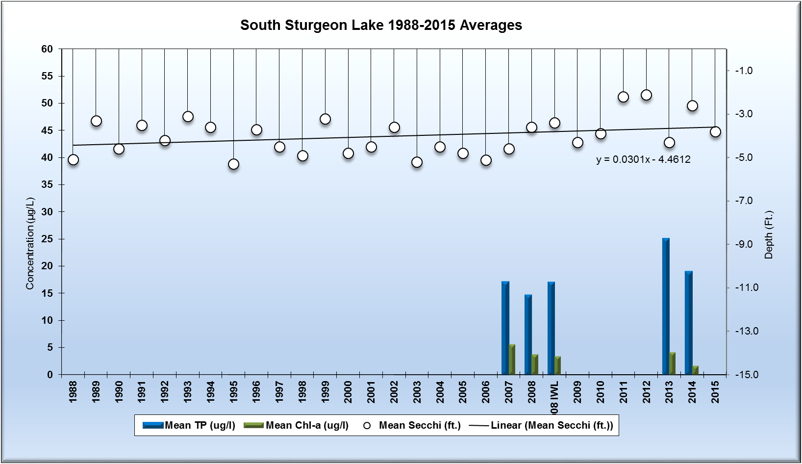

*Note: For detecting trends, a minimum of 8-10 years of data with 4 or more readings per season are recommended. Minimum confidence accepted by the MPCA is 90%. This means that there is a 90% chance that the data are showing a true trend and a 10% chance that the trend is a random result of the data.*

**Monitoring Recommendations**

Transparency monitoring at site 201 should be continued annually. It is important to continue transparency monitoring bi-weekly or at least monthly every year to enable year-to-year comparisons and to determine if the negative trend analyses is significant moving forward. It is also recommended that phosphorus and chlorophyll a monitoring should continue at site 201 every 2-3 years or as the budget allows, to track future water quality trends and to determine if the declining trend in water clarity is an indication of a declining trend in water quality with strong references to the other parameters. RMB Labs, based in Detroit Lakes would be a recommended resource for Water Quality lab services as well as statistical reporting. RMB has a highly skilled staff with a robust background in statistics and chemistry, coupled with a convenient sample transport system between Spee-Dee Delivery Services and RMB Labs. RMB has opened a sister Water Quality Lab at Itasca Community College as of January 2016, and will be a good local resource for general water quality analysis.