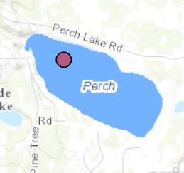**Perch Lake**

DNR Lake ID: 69-0932-00-203

County: St. Louis

Major Watershed: Little Fork River

Ecoregion: Northern Lakes & Forests

Surface Area: 340 acres

Maximum Depth: 21 feet

Water Quality Data: 5 years

Secchi Data: 17 years

## 2015 Water Quality Summary

Clarity monitoring results for Perch Lake in 2015 were slightly better than the lake’s historical average and within expected ranges for this region. The trophic status of Perch Lake is mesotrophic which is indicative of moderately clear, good quality lakes of intermediate depth, temperature and nutrient levels. Overall, Perch Lake appears to be in good condition and should be closely managed for protection of the resource.

**Perch Lake Water Quality**



**Carlson’s Trophic Status Index (TSI)**



*Note: Trophic State Indices (TSIs) are an attempt to provide a single quantitative index for the purpose of classifying and ranking lakes, most often from the standpoint of assessing water quality. TSIs ranges from clear lakes, low in nutrients (oligotrophic), to green lakes, with very high nutrient levels (hypereutrophic).*

**Historical Water Quality Summary**

Perch Lake’s historical data for total phosphorus and chlorophyll-a do not meet the minimum requirements for looking at trends. There is however 17 years of secchi data, of which 14 are consecutive, which provides sufficient data to perform long term trend analysis. Although the secchi data doesn’t show a “significant” positive trend, it is indicating a slight increase in clarity from 1995 to 2015 which is encouraging.

*Note: For detecting trends, a minimum of 8-10 years of data with 4 or more readings per season are recommended. Minimum confidence accepted by the MPCA is 90%. This means that there is a 90% chance that the data are showing a true trend and a 10% chance that the trend is a random result of the data.*

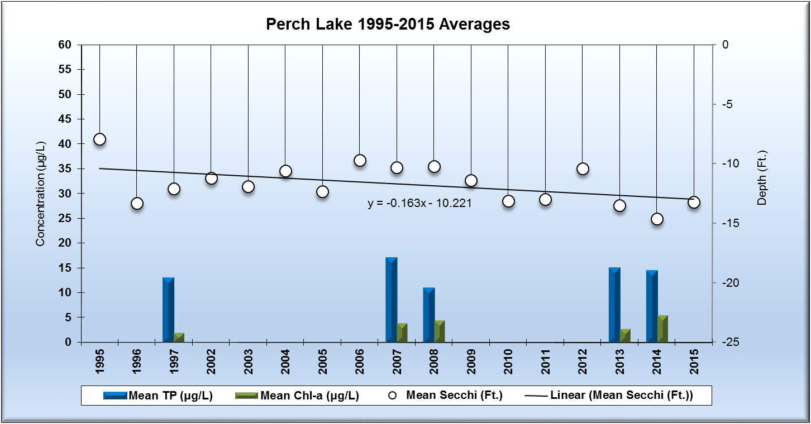

**Monitoring Recommendations**

Transparency monitoring at site 203 should be continued annually. It is important to continue transparency monitoring bi-weekly or at least monthly every year to enable year-to-year comparisons and trend analyses. Phosphorus and chlorophyll a monitoring should continue at site 203, every 3-5 years or as the budget allows, establishing future water quality trends. With the possibility of increasing clarity compared to other lakes in the nearby vicinity, this may be closer examined to determine what physical or chemical changes have or have not occurred since 1995-96 to the present that are influencing a positive trend in the clarity. RMB Labs, based in Detroit Lakes would be a recommended resource for Water Quality lab services as well as statistical reporting. RMB has a highly skilled staff with a robust background in statistics and chemistry, coupled with a convenient sample transport system between Spee-Dee Delivery Services and RMB Labs. RMB has opened a sister Water Quality Lab at Itasca Community College as of January 2016, and will be a good local resource for general water quality analysis.