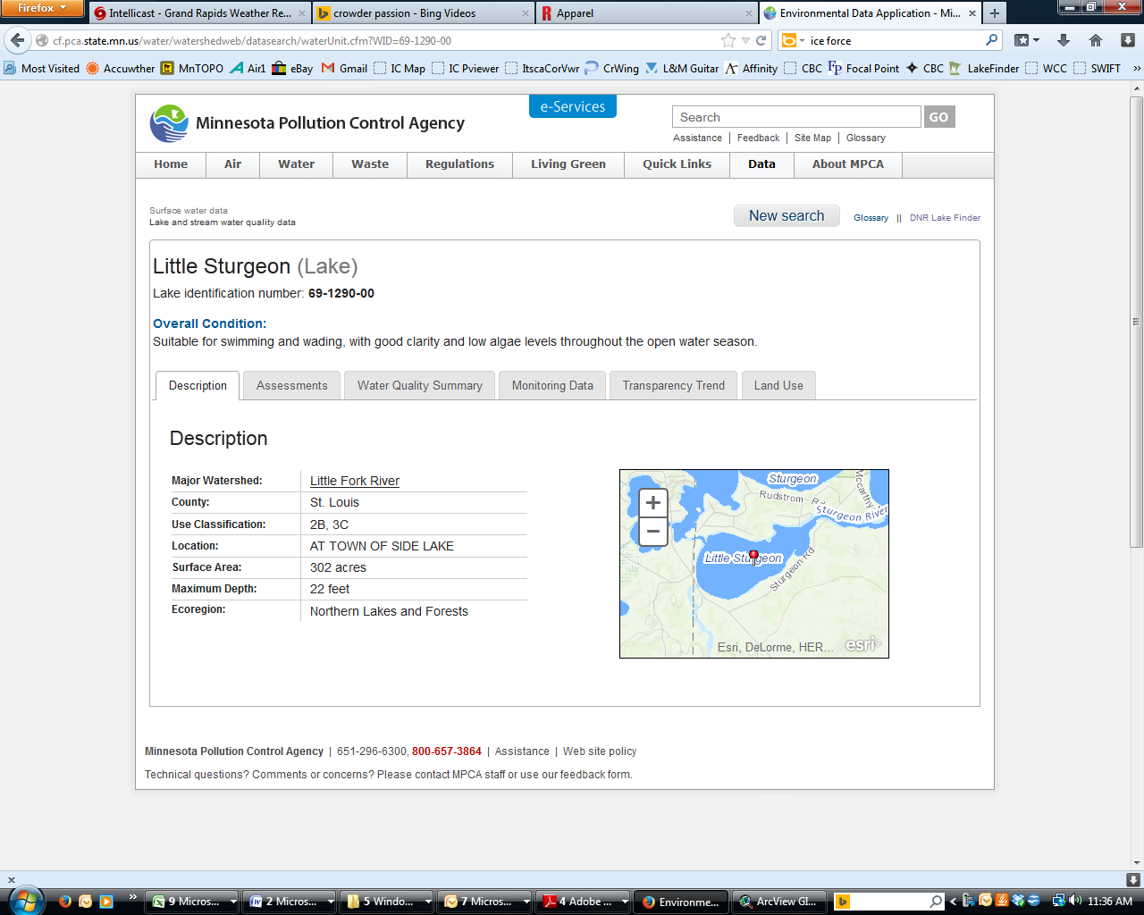**Little Sturgeon Lake**

DNR Lake ID: 69-1290-00-202

County: St. Louis

Major Watershed: Little Fork River

Ecoregion: Northern Lakes and Forests

Surface Area: 302 acres

Maximum Depth: 22 feet

Water Quality Data: 4 years

Secchi Data: 10 years

## 2015 Water Quality Summary

Clarity monitoring results for Little Sturgeon Lake in 2015 were very similar to the lake’s historical average but below expected ranges for this region. The trophic status of Little Sturgeon Lake is borderline eutrophic which means the lake is near a threshold where it likely experiences problems with algae blooms and macrophyte (submergent vegetation growth) problems. Although it is supportive of all swimmable/aesthetic uses it may experience periods each year where recreation is inhibited. Due to the high tannin stain of the water, algae blooms are limited in comparison with lakes that are clearer and is indicated by the lower TSI score for chlorophyll-a. Although the lake is classified as borderline eutrophic, further study is required to determine if its current status is a result of natural conditions or anthropogenic (human) causes.

**Little Sturgeon Lake Water Quality**



**Carlson’s Trophic Status Index (TSI) – Little Sturgeon Historical Averages**





*Note: Trophic State Indices (TSIs) are an attempt to provide a single quantitative index for the purpose of classifying and ranking lakes, most often from the standpoint of assessing water quality. TSIs ranges from clear lakes, low in nutrients (oligotrophic), to green lakes, with very high nutrient levels (hypereutrophic).*

## Historical Water Quality Summary

Little Sturgeon Lake’s historical data for total phosphorus and chlorophyll-a do not meet the minimum requirements for looking at trends. There is however 10 years of secchi data which provides sufficient data to perform long term trend analysis. The secchi data doesn’t show a “significant” positive trend, though there may be a weak trend towards loss of clarity, it is indicating a relatively steady state from 1994 to 2015.

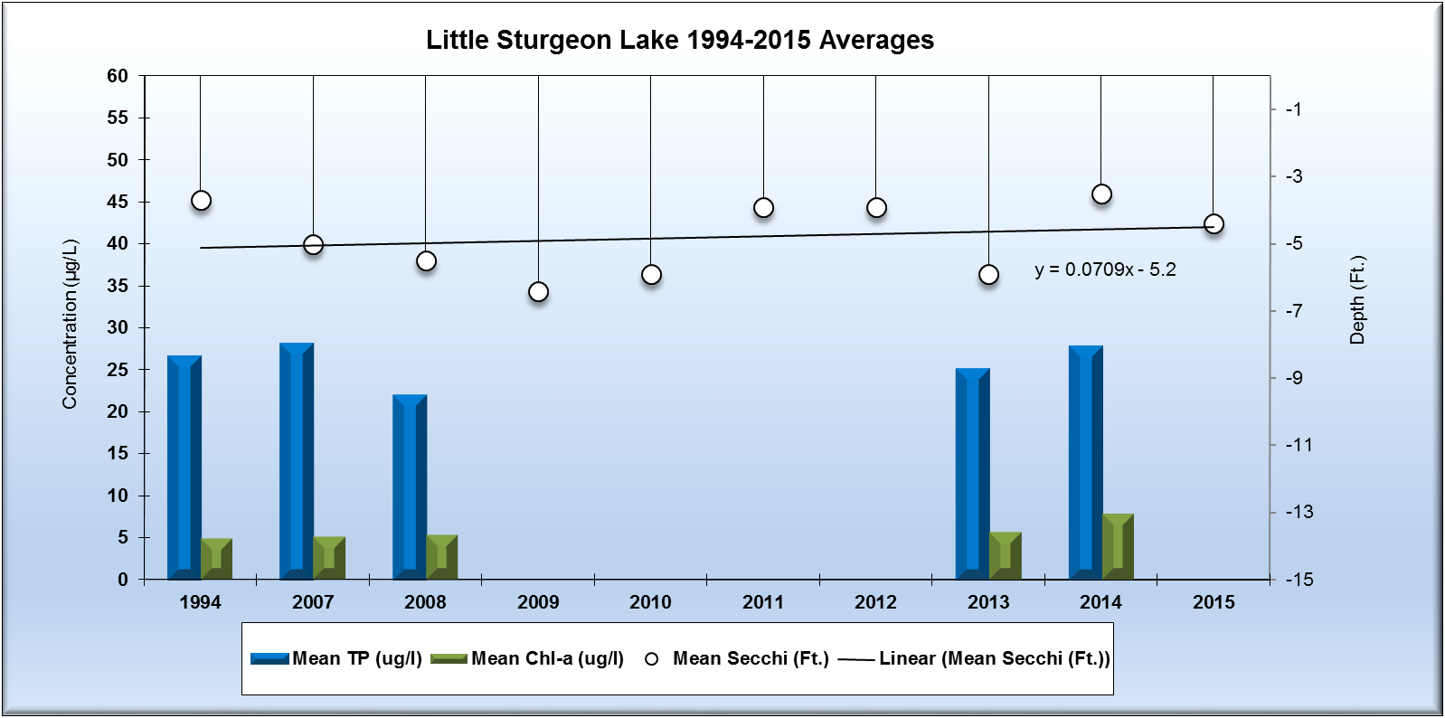

*Note: For detecting trends, a minimum of 8-10 years of data with 4 or more readings per season are recommended. Minimum confidence accepted by the MPCA is 90%. This means that there is a 90% chance that the data are showing a true trend and a 10% chance that the trend is a random result of the data.*

**Monitoring Recommendations**

Transparency monitoring at site 202 should be continued annually. It is important to continue transparency monitoring bi-weekly or at least monthly every year to enable year-to-year comparisons and trend analyses. Phosphorus and chlorophyll a monitoring should continue at site 202, every 3-5 years or as the budget allows, to track future water quality trends. RMB Labs, based in Detroit Lakes would be a recommended resource for Water Quality lab services as well as statistical reporting. RMB has a highly skilled staff with a robust background in statistics and chemistry, coupled with a convenient sample transport system between Spee-Dee Delivery Services and RMB Labs. RMB has opened a sister Water Quality Lab at Itasca Community College as of January 2016, and will be a good local resource for general water quality analysis.