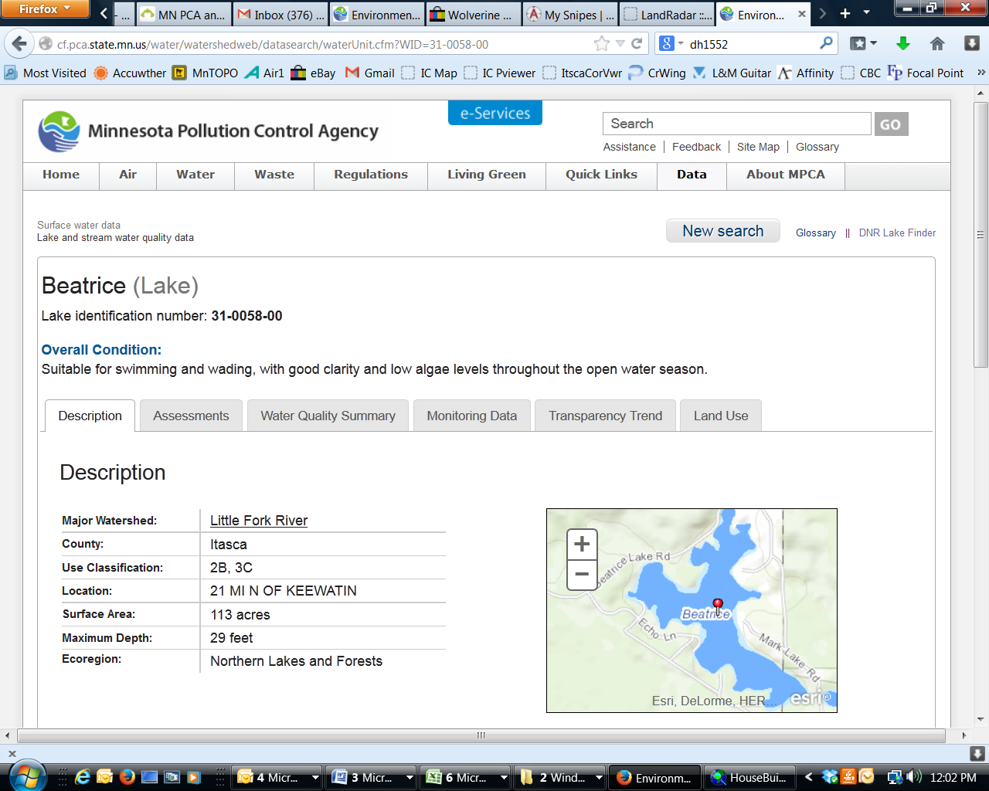**Beatrice Lake**

DNR Lake ID: 31-0058-00-201

County: Itasca

Major Watershed: Little Fork River

Ecoregion: Northern Lakes and Forests

Surface Area: 113 acres

Maximum Depth: 29 feet

Water Quality Data: 9 years

Secchi Data: 25 years

**2015 Water Quality Summary**

Water quality monitoring results for Beatrice Lake in 2015 were very close to the lake’s historical average and within the expected ranges for the Northern Lakes and Forests Ecoregion. The trophic status of Beatrice Lake is mesotrophic which is indicative of moderately clear, good quality lakes of intermediate depth, temperature and nutrient levels. Overall, Beatrice Lake water quality is good with respect to other lakes in the region, but it is clearly showing a declining trend in transparency over the past decade which is cause for concern and increased vigilance involving land use decisions.

**Beatrice Lake Water Quality**



**Carlson’s Trophic Status Index (TSI) – Beatrice Lake Historical Averages**



*Note: Trophic State Indices (TSIs) are an attempt to provide a single quantitative index for the purpose of classifying and ranking lakes, most often from the standpoint of assessing water quality. TSIs ranges from clear lakes, low in nutrients (oligotrophic), to green lakes, with very high nutrient levels (hypereutrophic).*

## Historical Water Quality Summary

The 25 years of secchi data for Beatrice Lake show a somewhat “significant” negative trend since 1991. This means lake is not as clear as it has been in the past and its clarity is continuing to decrease gradually.

MPCA reports: *The median transparency for Beatrice Lake from 1981 to 2011 decreased by 0.64 feet per decade and is evidence for a long-term negative trend. A plausible range for the long-term trend is between no trend and a decrease of 1.36 feet per decade*.

Beatrice Lake’s nine years of historical data for total phosphorus and chlorophyll-a would suggest there has been a decrease in phosphorus and chlorophyll-a concentrations since 1994, but that is strongly influenced by the poor water quality years of 1994-95. When we look at the shorter time period (1998-2014) there is indication of an increase in phosphorus and chlorophyll-a levels but there is no definite trend (variability in data is currently inconclusive) and further monitoring is required to confirm if there is a declining trend in water quality for Beatrice Lake. To achieve ten years of Phosphorus and Chlorophyll-a monitoring would provide a clearer view into the current trends. The last three years have consecutive data, and do show increases in both Total Phosphorus and Chlorophyll-a, while showing a decrease in Beatrice’s water clarity.

Zooplankton is part of the foundation for aquatic food webs, as they consume phytoplankton (algae) and are preyed upon by adult fish. Since they have such a key role in the functioning of the aquatic ecosystem, they are also good indicators of lake productivity. In 2014, the zooplankton community was sampled once a month June through September and analyzed by the MNDNR Aquatic Biology Division. The conclusion was that nothing unusual was observed in the population of zooplankton found in Beatrice Lake. A diverse zooplankton community was observed, with both densities and biomass that were slightly high compared to other lakes in the Northern Lakes and Forests Eco-region of Minnesota, though nothing extraordinary that would contribute to a declining trend in water clarity.

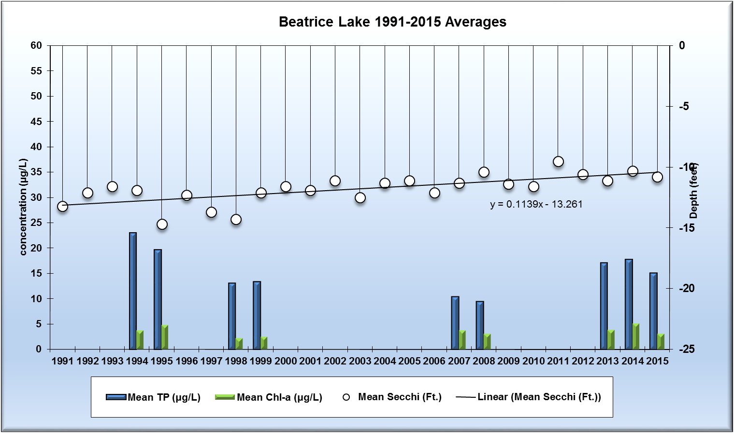

*Note: For detecting trends, a minimum of 8-10 years of data with 4 or more readings per season are recommended. Minimum confidence accepted by the MPCA is 90%. This means that there is a 90% chance that the data are showing a true trend and a 10% chance that the trend is a random result of the data.*

**Summary**

Beatrice Lake is showing a significant trend in loss of water clarity, which raises concern that the lake’s water quality is declining. Trend analysis for phosphorus and chlorophyll-a data, which have been collected more sporadically, is inconclusive at this time as to whether or not water quality is declining. Looking at longer term trends, they appear relatively stable and even a slight decline, though there are indications that phosphorous levels have been increasing since 1998, which with more data points is likely more correct. There appeared to be some bad water quality years in 1994-1995 that significantly affect the trends for Total Phosphorus and Chlorophyll-a concentrations and the historical average. In addition to data collected on the lake, the Lake Water Quality Sensitivity Analysis Report (Reed, 2004) states that Beatrice Lake is limited in its ability to assimilate nutrients entering the lake and based on predictive modeling. Increased sensitivity to phosphorus loads means that land disturbance and development has a greater potential for impacting lake water quality in comparison to deeper lakes or those with outlets. Although it is unclear at this time whether or not the decline in transparency is linked solely to development, knowing the lake’s susceptibility to impacts should spur community education and awareness efforts to encourage better land management and the protection of Beatrice Lake’s future.

**Recommendations**

Transparency monitoring at site 201 should be continued annually. It is important to continue transparency monitoring bi-weekly or at least monthly during the open water season, every year to enable year-to-year comparisons and determine if the negative trend in clarity continues. It is also recommended that phosphorus and chlorophyll-a monitoring continue at site 201, once a month May through September annually to track future water quality trends and confirm whether or not the decline in water clarity is a result of increased phosphorus and/or algae levels in the lake. Since there are three recent contiguous years of data, it is strongly encouraged to continue this effort to provide an accurate basis for trends. Trends are best established with 8-10 years of continuous data points. If it is not economically feasible to monitor the chemistry every year, then every 2-3 years, or as possible is recommended. Land owners should be made aware of the declining trend in water clarity and worked with to reduce impervious surface/sediment runoff. Also, due to sandy soils and shallow aquifer systems, residents are strongly encouraged to have their septic systems inspected and upgraded if necessary. Ineffective septic systems around Beatrice Lake have a greater adverse impact on water quality due to the sensitivity of the lake to inputs.

RMB Labs, based in Detroit Lakes would be a recommended resource for Water Quality lab services as well as statistical reporting. RMB has a highly skilled staff with a robust background in statistics and chemistry, coupled with a convenient sample transport system between Spee-Dee Delivery Services and RMB Labs. RMB has opened a sister Water Quality Lab at Itasca Community College as of January 2016, and will be a good local resource for general water quality analysis.