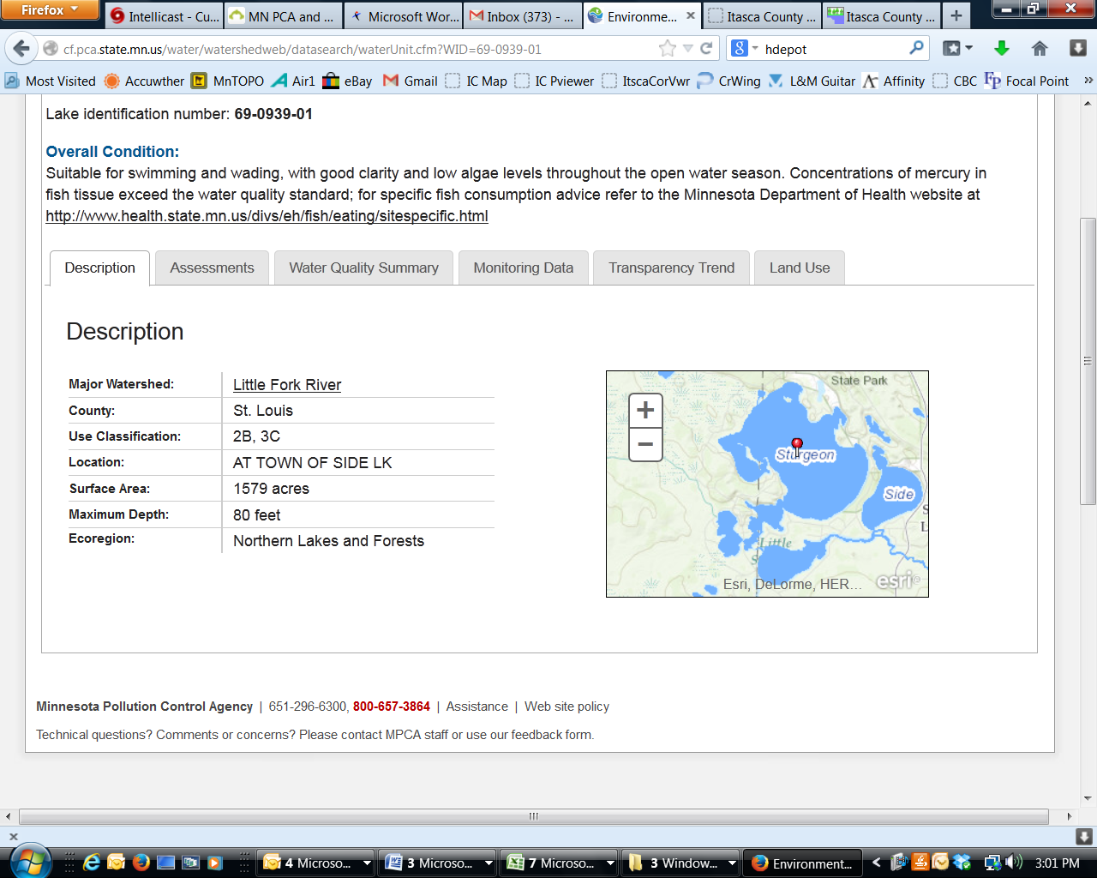**Sturgeon Lake**

DNR Lake ID: 69-0939-00-201

County: St. Louis-Itasca

Major Watershed: Little Fork River

Ecoregion: Northern Lakes and Forests

Surface Area: 1579 acres

Maximum Depth: 80 feet

Water Quality Data: 5 years

Secchi Data: 22 years

## 2015 Water Quality Summary

Clarity monitoring results for Big Sturgeon Lake in 2015 were very similar to the lake’s historical average and within expected regional ranges. The trophic status of Big Sturgeon is mesotrophic which is indicative of moderately clear, good quality lakes of intermediate depth, temperature and nutrient levels. Overall, Big Sturgeon Lake appears to be in good condition and should be closely managed to protect it from future degradation.

**Big Sturgeon Water Quality**



**Carlson’s Trophic Status Index (TSI) – Sturgeon Lake Historical Averages**



*Note: Trophic State Indices (TSIs) are an attempt to provide a single quantitative index for the purpose of classifying and ranking lakes, most often from the standpoint of assessing water quality. TSIs ranges from clear lakes, low in nutrients (oligotrophic), to green lakes, with very high nutrient levels (hypereutrophic).*

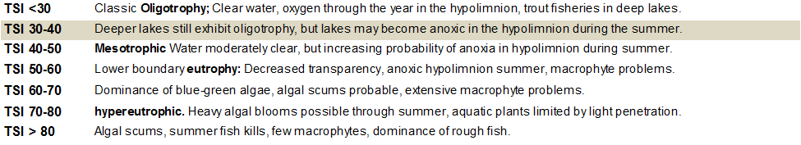

## Historical Water Quality Summary

Big Sturgeon Lake’s historical data for total phosphorus and chlorophyll-a do not meet the minimum requirements for looking at trends. There is however a database of 22 years of secchi data which provide sufficient data to perform long term trend analysis.

MPCA reports: *The median transparency for Big Sturgeon from 1986 to 2011 increased by 0.00 feet per decade. Given the variability over these years, there is no evidence of a long-term trend in either direction. A plausible range for the long-term trend is between no trend and a decrease of 0.55 feet per decade.*

Basically, amidst the highs and lows, the lake’s water clarity has remained the stable since 1986. Data from the last decade was also reviewed and also indicated no trends. There are some outlier years in 1991-92 and 1996-97 which are abnormally low and should be reviewed closer for accuracy. Additionally, it appears that within the last decade there is a very weak trend towards loss of clarity, which should warrant vigilance.

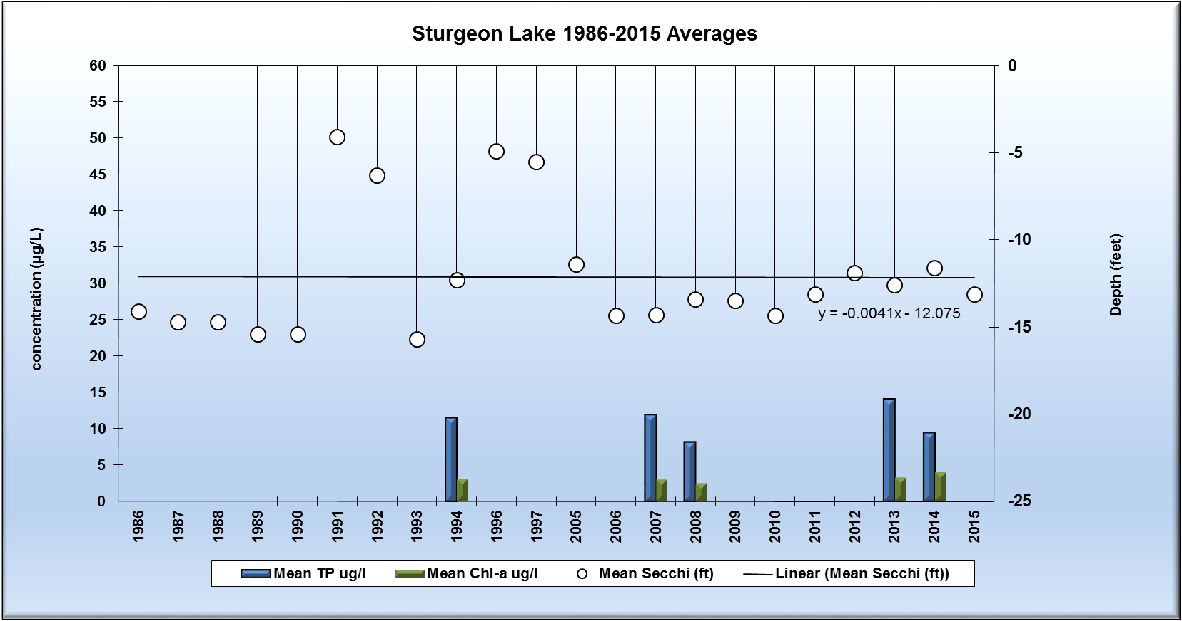

*Note: For detecting trends, a minimum of 8-10 years of data with 4 or more readings per season are recommended. Minimum confidence accepted by the MPCA is 90%. This means that there is a 90% chance that the data are showing a true trend and a 10% chance that the trend is a random result of the data.*

**Monitoring Recommendations**

Transparency monitoring at site 202 should be continued annually. It is important to continue transparency monitoring bi-weekly or at least monthly every year to enable year-to-year comparisons and trend analyses. Phosphorus and chlorophyll-a monitoring should continue at site 202, every 3-5 years or as the budget allows, contributing to future water quality trends. RMB Labs, based in Detroit Lakes would be a recommended resource for Water Quality lab services as well as statistical reporting. RMB has a highly skilled staff with a robust background in statistics and chemistry, coupled with a convenient sample transport system between Spee-Dee Delivery Services and RMB Labs. RMB has opened a sister Water Quality Lab at Itasca Community College as of January 2016, and will be a good local resource for general water quality analysis.